PROJECT 2 – What’s the Weather?
You will each be investigating the average monthly temperatures of a city of your choosing (every person must choose a unique city). Once you pick a city you will record the data and then follow the directions given for each part.
A) CITY –
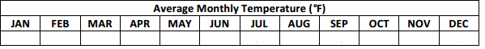
B) Use this data to write a function representing the temperature, f(m), in month m, with January=0.

C) Graph this function on the axes below, labeling any critical values.

D) Imagine that the average high temperature for the hottest month in your city increases by as much as 10 degrees by 2050. Assuming that the average low monthly temperature stays the same, write a second function modeling this change.

E) Use the function in part D to predict the new average monthly temperature for October.

F) Although only 12 data points are given in the table above, the function modeled above is continuous. Should average monthly temperature be expressed as a continuous function? Why or why not?

G) The table below displays the average monthly rainfall for Central Park.
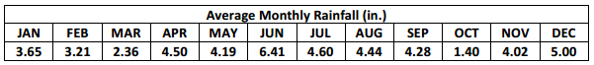
Your friends Sam wants to model this data using a function similar to the one that you have written. Do you think this is a good idea? Why or why not?

